**LINUX ASSIGNMENT-2**

1)  Create user with name Techie and provide sudo access to user : sudo adduser techie

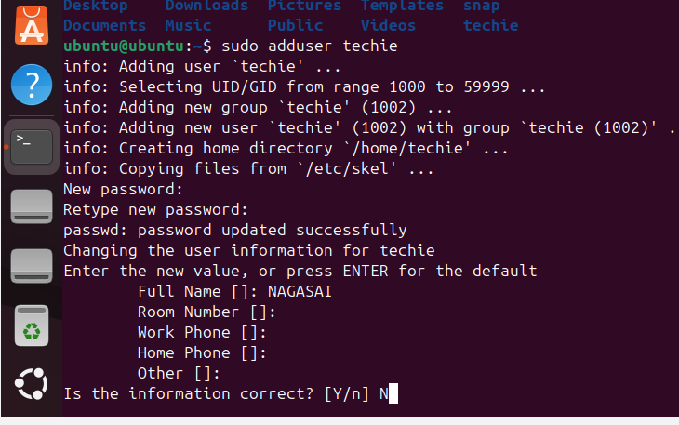  
2)  Navigate to the home directory.- cd ~

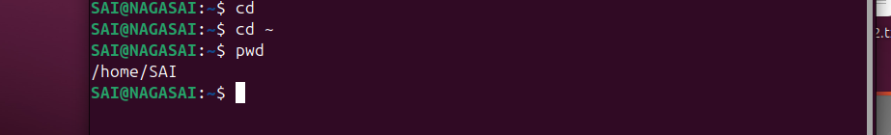

3)  Create a new directory. –MKDIR Directory name

4)List the contents of the directory - LS



  
  
5)  Change the current directory. -CD

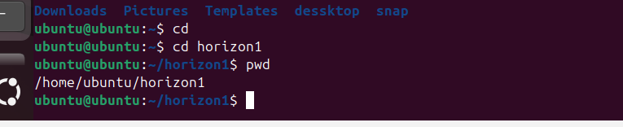

6)  Create a new empty file- touch filename

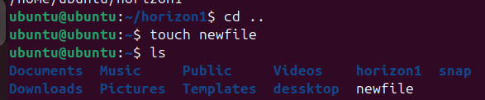

7) view the contents of the file-cat filename

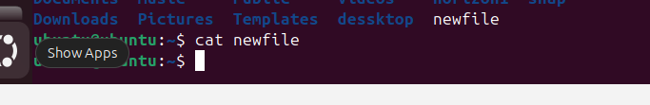  
8)  Copy a file to another location.-cp

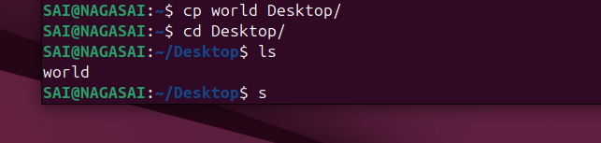

9)  Move a file to another location-mv source path destination path

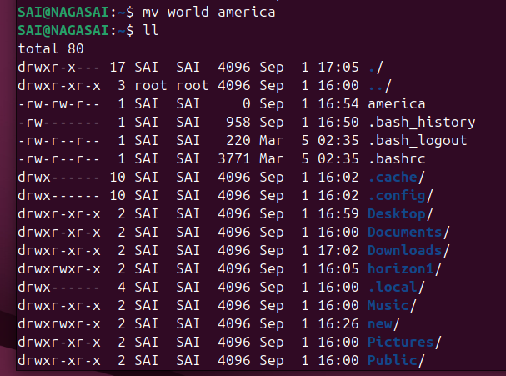

10) Rename a file.-mv



11) Delete a file.-rm

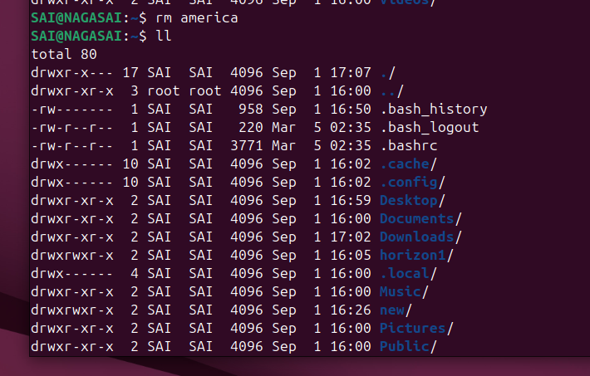

**12) Grant or revoke permissions on a file or directory**.-chmod

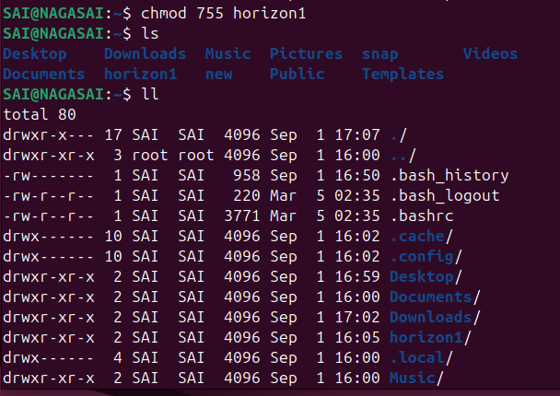

13) View the current date and time.

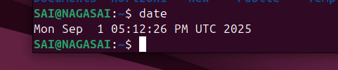

14) Check the system uptime.

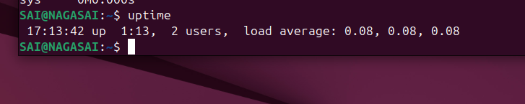  
15) View the running processes.

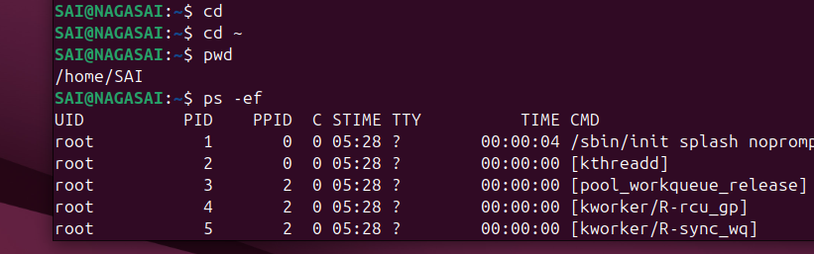

16) Kill a running process.

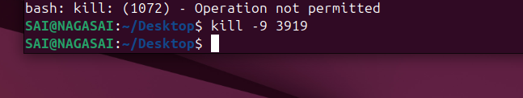

17) Install a package using the package manager (e.g., apt or yum).-sudo apt install nginx

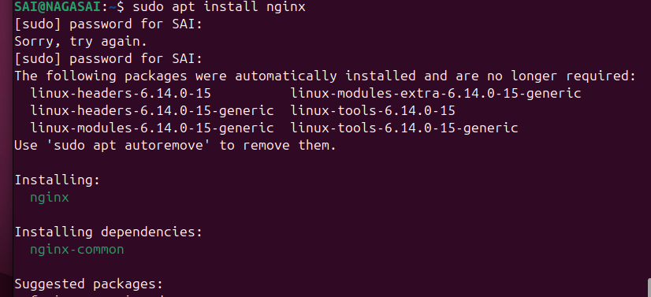  
18) Update the system packages.-sudo apt upgrade

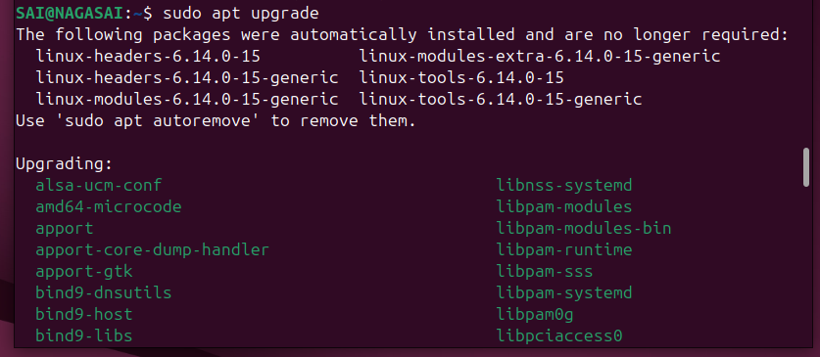  
19) Create a symbolic link.

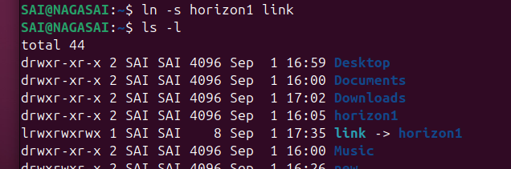

20) Search for files using the find command.

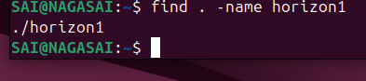

21) Compress and decompress files using tar.-TAR CVF newfile old name/

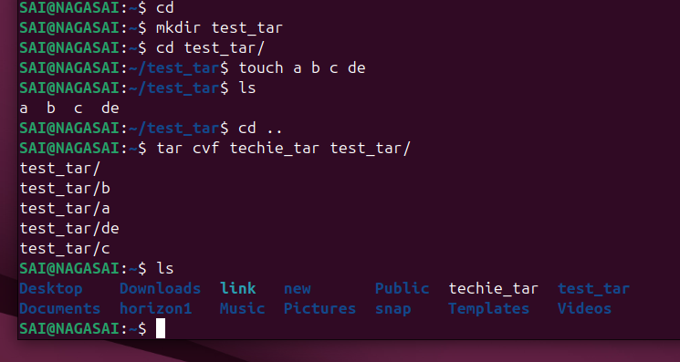  
22) Monitor system resources with top or htop.-top

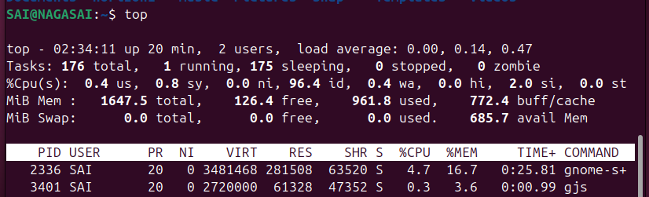  
23) Create and manage user groups.

24) Set up SSH password less authentication.

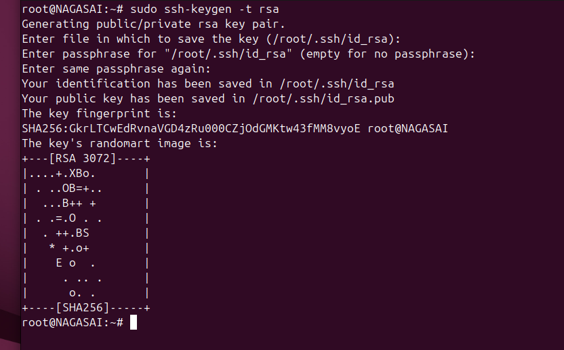  
25) Monitor log files using tail or grep.

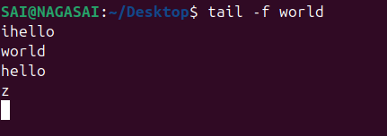

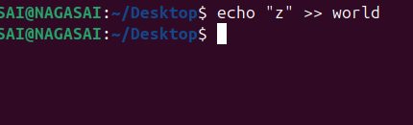

26) Set up a web server (e.g., Apache or Nginx).

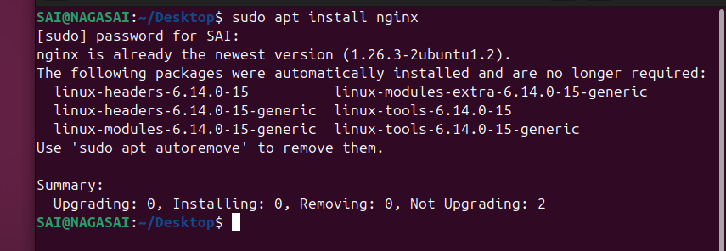

27) Configure and secure a MySQL Database.

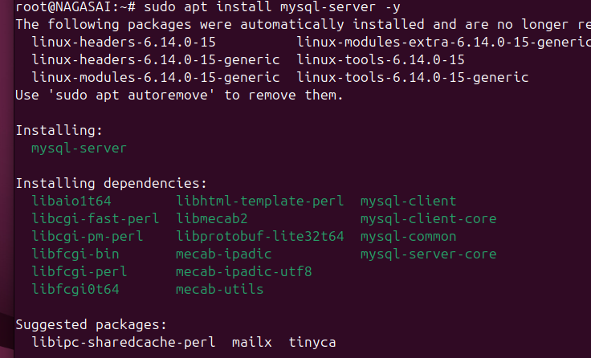  
28) Set up a Application Server (e.g.,Apache Tomcat)

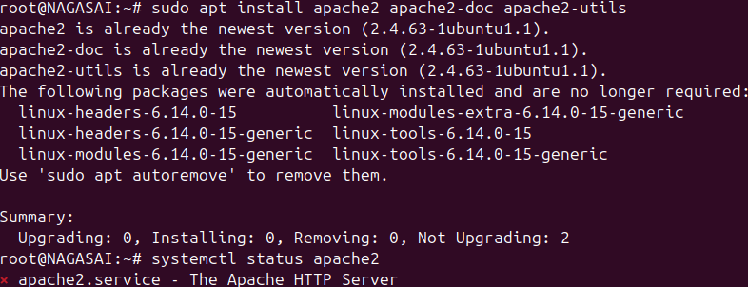  
30) Print specific columns from a delimited file.

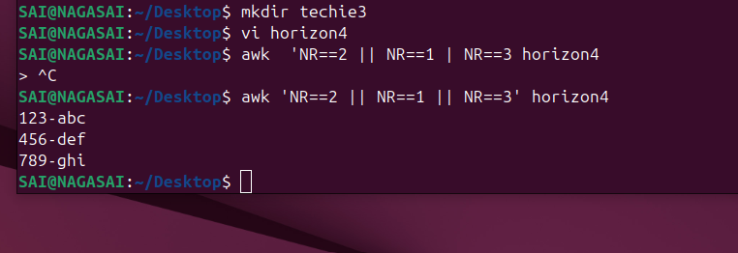  
31) Filter and print lines based on a specific pattern or condition.

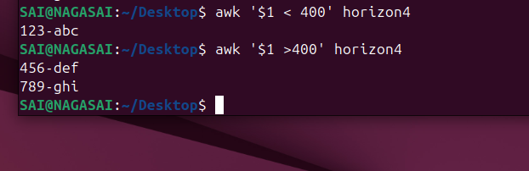  
32) Calculate and print the average, sum, or other statistics of a column.

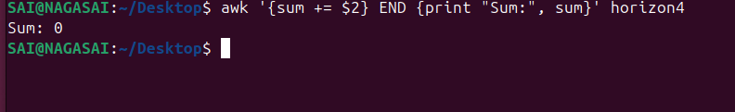  
33) Perform string manipulation, such as extracting substrings or changing case.

  
34) Count the occurrences of a specific pattern in a file.

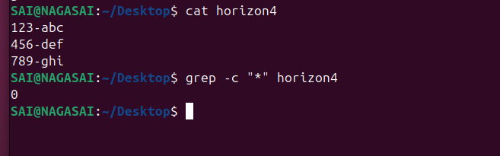  
35) Sort lines based on a specific field or column.

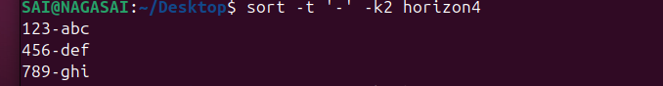

36) Merge multiple files based on a common field or column.

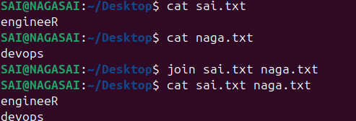

37) Substitute text in a file using search and replace.

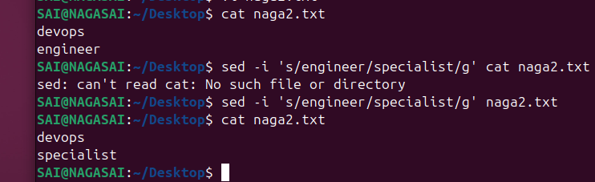  
38) Delete specific lines based on a pattern or line number.

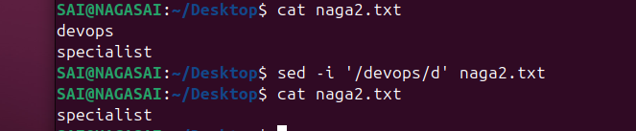  
39) Append or insert text before or after a specific pattern or line.

  
40) Print only specific lines from a file.

  
41)  Copy file from linux to windows machine  
42)  5 use cases for AWK and 5 use cases for sed